Punnetts, Pedigrees and Karyeotypes. . . Oh My! Name: __________________________ Per:____

Part I: Punnett Squares

Punnett Squares are a useful tool to find the probability of a certain genetic combination in offspring from a potential cross. The genotype of each parent is determined and assorted evenly between the four combinations possible. First, make a key for the traits and the letters you choose to represent them. Then, draw a Punnett Square, complete it and provide genotype and phenotype ratios as well as the percent chance for the inheritance of each trait. SHOW ALL YOUR WORK OR YOU WILL NOT RECEIVE POINTS!!

Complete dominance
In cases of complete dominance, one gene is dominant and the other is recessive. The letters used would be a capital letter derived from the dominant trait (dominant) and a lower case of the same letter for the recessive trait. Example: Tall = T, Short = t

1. In cats, the spotting of the coat is due to a recessive gene, while a solid colored coat is dominant. What types of offspring might be produced by a cross between two spotted animals?

2. About 7% of Caucasians in the U.S. cannot smell the odor of musk. If both parents cannot smell musk, all of the children will be unable to smell it. On the other hand, two parents who can smell musk, generally have children who can also smell it and only a few of their offspring will be unable to smell musk. Determine the genotypes of two musk-smelling parents who have 3 children who can smell musk and 1 who cannot. Show the cross below.

3. How it is possible to have a black lamb from a cross between a white ewe and a white ram? Show the cross below.

4. In Shmoos from the planet Shmoovaria, pink fur is dominant over red fur. What are the chances of a red parent and a heterozygous pink parent having a pink child?

5. In humans, the ability to roll the tongue is a dominant trait. What are the possibilities of a couple having a non-tongue rolling child if they are both homozygous dominant for tongue rolling?

Incomplete dominance
In cases of incomplete dominance, neither gene is fully dominant over the other, so they are expressed as a mix of the two. Each trait is represented with the capital letter of their description. Example: White = W, Red = R

4. In guinea pigs, neither yellow (Y) nor white (W) color dominates. They blend to form a cream color in the heterozygous. Cross a cream-colored guinea pig with a yellow one, giving genotypes, phenotypes and ratios.

5. In four o’clock plants, the flowers may be white or red in the purebred plant (homozygous). In the hybrid (heterozygous) plant, the flowers are pink. Cross two pink flowers and give the genotypes, phenotypes and ratios. Let R = red and W= white.

Codominance
In cases of codominance, both alleles are dominant and both are expressed evenly. For example, a cross between a white flower (W) and a purple flower (P) would produce a purple and white spotted flower.

- In some chickens, the gene for feather color is controlled by codominance. The allele for black is B and the allele for white is W. The heterozygous phenotype is known as erminette (black and white spotted). Show a cross between a Black and a White chicken.
- What is the genotype for black chickens? ____
- What is the genotype for white chickens? ____
- What is the genotype for erminette chickens? ____

- In shorthorn cattle, when a red bull (RR) is crossed with a white cow (WW), all the offspring are roan—a spotted, red and white or milky red color. What offspring are expected from mating a roan bull and a roan cow? Show the Punnett Square, phenotypes and genotypes.

Codominance and Multiple Alleles: Blood Type

Human blood types are determined by genes that follow the CODOMINANCE pattern of inheritance with three possible alleles children can receive. There are two dominant alleles (A and B) and one recessive allele (O).

Write the genotype for each person based on the description:

  - Homozygous for the “B” allele ______
  - Heterozygous for the “A” allele ______
  - Type O ______
  - Type “A” and had a type “O” parent ______
  - Type “AB” ______

- Draw a Punnett square showing all the possible blood types for the offspring produced by a type “O” mother and a Type “AB” father.

- Pretend that Beyonce is homozygous for the type B allele, and Jay-Z is type “O.” What are all the possible blood types of their baby?

- Two parents think their baby was switched at the hospital. Its 1968, so DNA fingerprinting technology does not exist yet. The mother has blood type “O,” the father has blood type “AB,” and the baby has blood type “B.”
  - Mother’s genotype: _______
  - Father’s genotype: _______
  - Baby’s genotype: ______ or ________
  - Complete a Punnett square showing all possible genotypes for children produced by this couple
  - Was the baby switched? How do you know?

Part II: Pedigree Analysis
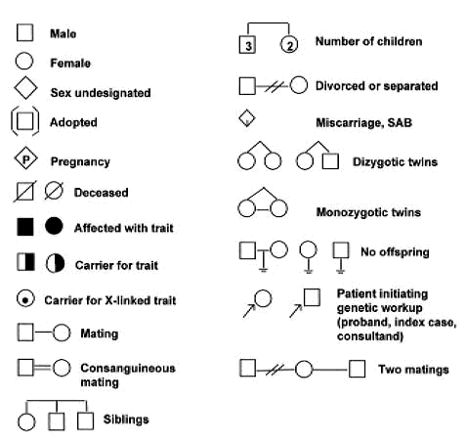
A pedigree is used by genetic counselors to trace particular traits throughout a family history. This is useful to determine where genetic changes may have occurred, and also to see who passsed on certain genes.

Part II: Pedigree Analysis
= Huntington’s
Disease

I
II
IV
1
2
1
2
3
4
2
1
1
2
3
3
4

8

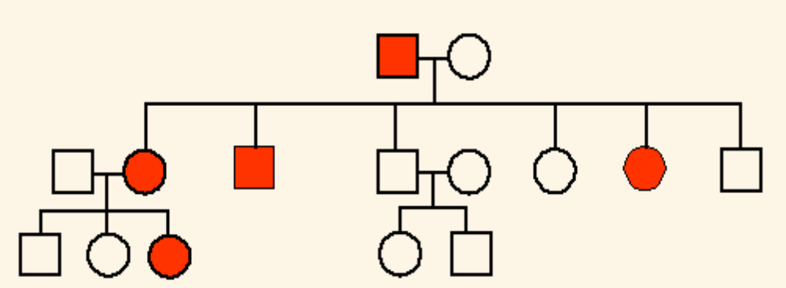
I
1 2

II 1 2 4 5
3 6 7 8

III
1 2 3 4 5

1. Which members of the family above are afflicted with Huntington’s Disease? ____________________________

2. There are no carriers for Huntington’s Disease- you either have it or you don’t.
With this in mind, is Huntington’s disease caused by a dominant or recessive trait? ___________________

3. How many children did individuals I-1 and I-2 have? _______________________________________________

4. How many girls did II-1 and II-2 have? ___________ How many have Huntington’s Disease? _______________

5. How is individual III-2 and II-4 related? _____________________ I-2 and III-5? _______________________

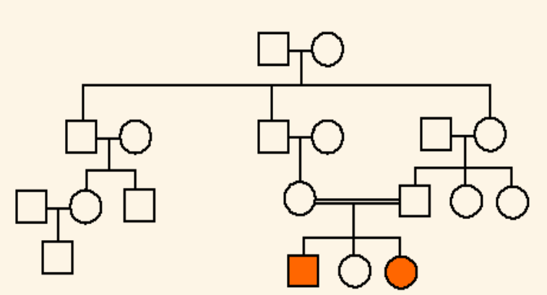
6. The INCOMPLETE pedigree to the right shows the passing on of Hitchhiker’s Thumb in a family. Fill in any carriers that you can identify as you work along. Is this trait dominant or recessive? ____________________

7. How do you know? ______________________

8. How are individuals III-1
and III-2 related? ________________________

9. Name 2 individuals that
have hitchhiker’s thumb. __________________
III

10. Name 2 individuals that were
carriers of hitchhiker’s thumb. ______________

11. Is it possible for individual IV-2 to be a carrier? __________ Why? __________________________________

12. The pedigree to the right shows the passing on of
colorblindness. What sex can be carriers of
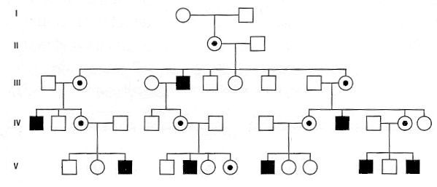
colorblindness? _________________

13. With this in mind, how do you think it is passed on in families? __________________
14. Why does individual IV-1 have colorblindness?
_______________________________
15. Why do most of the daughters in generation II carry the colorblind gene? _________________________
16. How could a female inherit colorblindness?

17. Make a pedigree for the family described below: Brown eyes are dominant over eyes of another color (blue, green, hazel, violet, gre, etc.). Dale had brown eyes and marries Martha, who has green eyes. Their three children are Arthur (brown eyes), Violet (green eyes), and Lindsay (brown eyes). When they grow up, Arthur marries Estelle who has blue eyes. Violet marries Nathan who has green eyes and Lindsay marries Tom who has brown eyes. Estelle, Violet, and Lindsay are all expecting boy children. What are the possible outcomes for their children’s eye colors?

Draw the pedigree and explain the eye color possibilities for these boys.

18. Make a pedigree for the family described below:
Luis marries Maria and they have 5 children (in order from oldest to youngest): Luis Jr., Jorge, Inez, Isabella and Marcos. When Jorge turns 6, the family finds out he has Duchenne Muscular Dystrophy, a rare recessive disorder inherited on the X-chromosome. It causes muscle and nerve damage and will usually lead to death before the age of 13. Luis Jr. is tested and is found to be unaffected by the disorder, but Maria and Luis want to know what the chances are that their other children will have it.

Draw a pedigree to show the possibilites for Inez, Isabella and Marcos, and advise the family about whether or not they should be concerned about having another baby.
Karyotyping: Part III

- Look at the karyotype in Figure 1 below. Notice the two sex chromosomes, pair number 23, do not look alike. They are different because this karyotype is of a male, and a male has an X and a Y chromosome. Circle the Y chromosome in the Karyotype below.
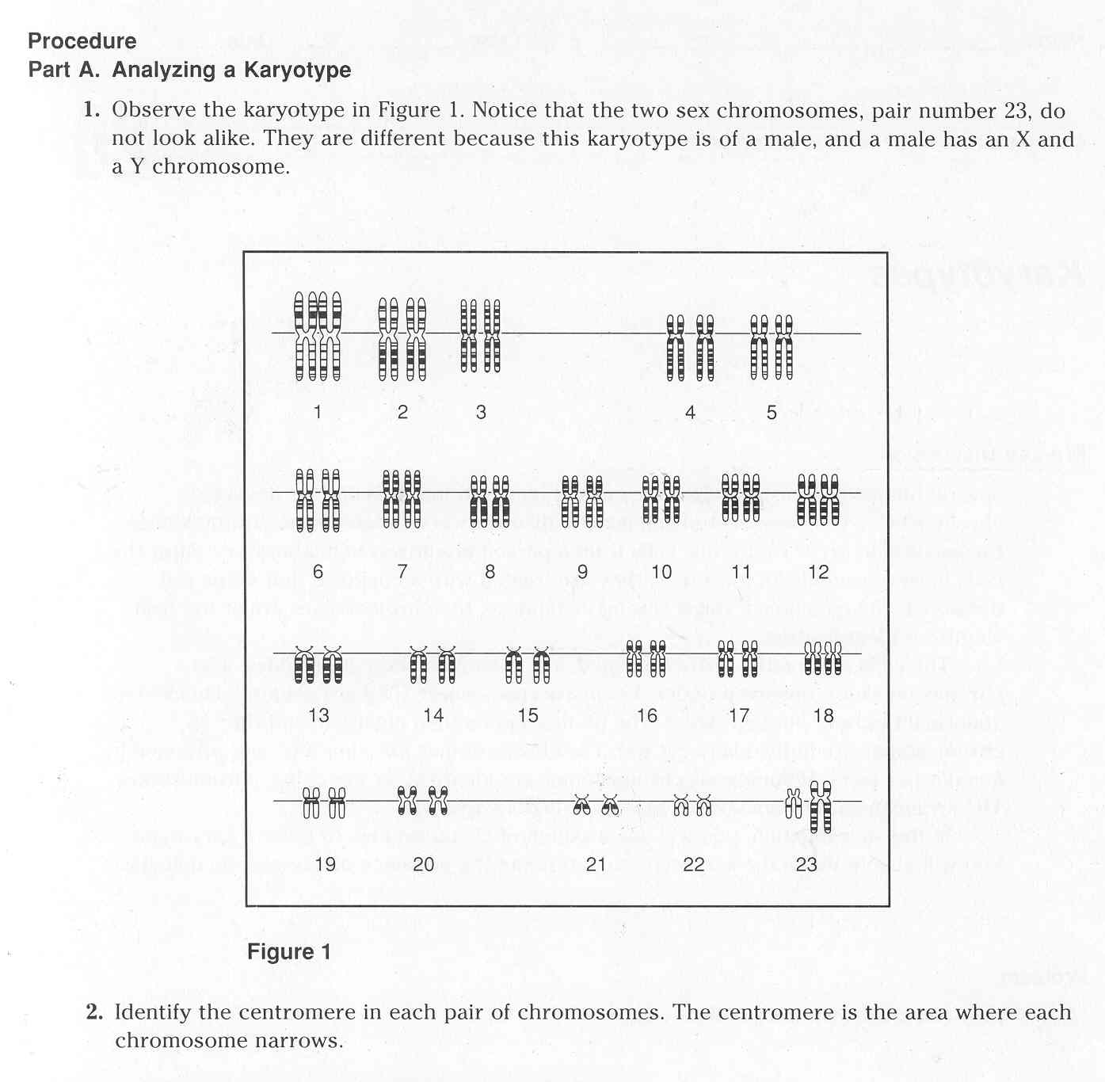

- Notice the center point of each chromosome. This is called a centromere. Is there a line running through each centromere in the picture above? Circle YES NO
- How many chromosomes does a normal person have? Circle 23 46

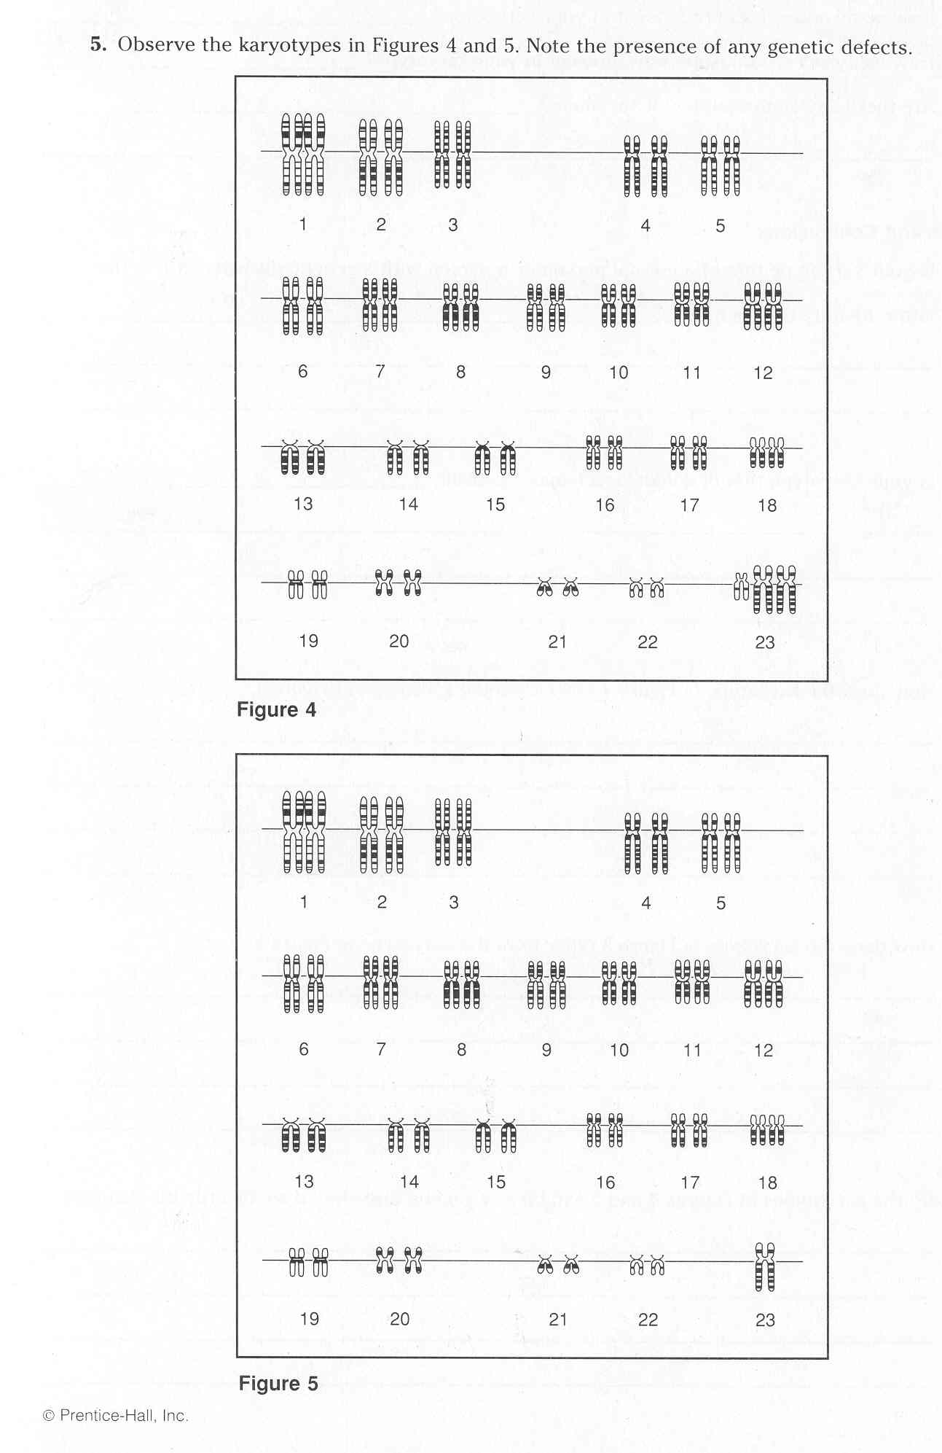
4. Look at the karyotype labeled figure Do you see any chromosomal abnormalities? YES NO

5. What chromosomes are abnormal?
AUTOSOME SEX

6. What is abnormal about these chromosomes?

7. Look at the karyotype to the left is it:
MALE or FEMALE
NORMAL or ABNORMAL

8. Which chromosome is the longest and has the most genes? 1 or 21

9. Which chromosome is the shortest and has the fewest genes? 2 or 22

10. In a normal karyotype how many
autosomal chromosomes are there? ___________________________

11. In a normal karyotype how many sex chromosomes are there? ____________

12. One type of nondisjunction mutation is trisomy 21. What is another name for it? _____________________________________________________

13. Identify the disorder in karyotype Figure 4. ______________________

14. Identify the disorder in karyotype Figure 5. ______________________

15. What syndrome does the person below have? ______________
16. This person is a: MALE or FEMALE

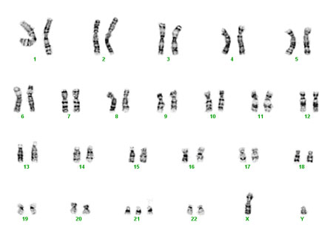

Karyotype worksheet
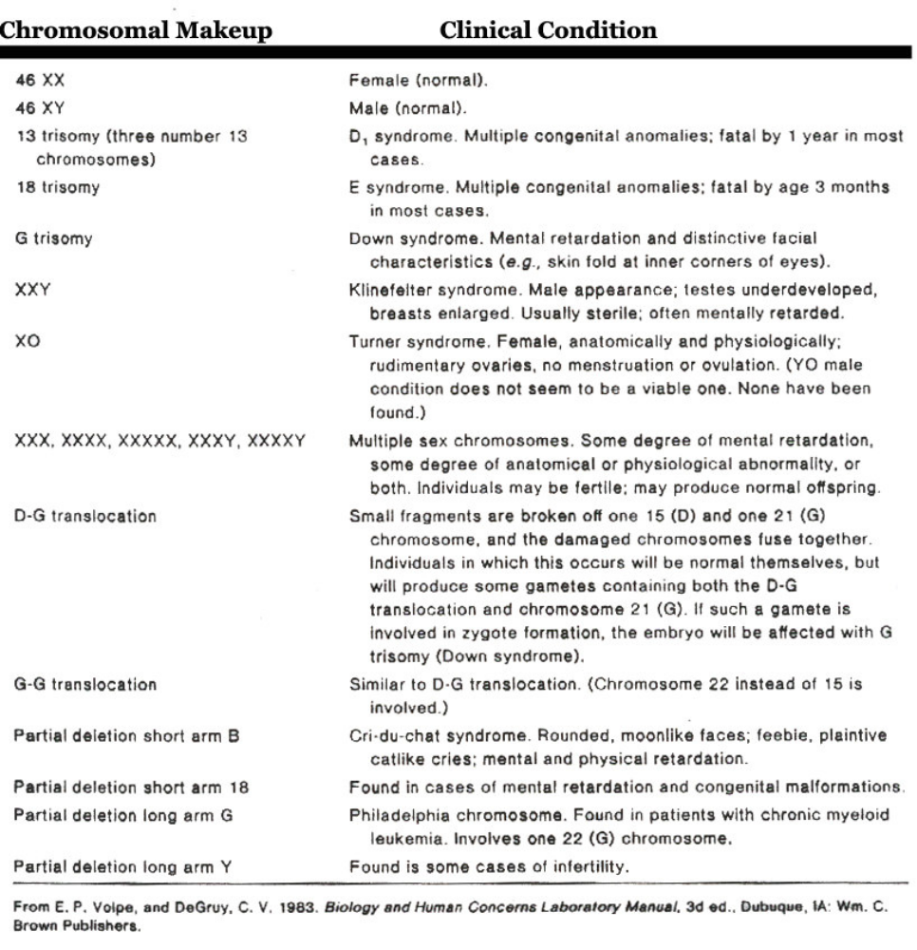
(Only 1 X chromosome)
(21 trisomy)

Patient A
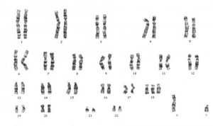

Patient B
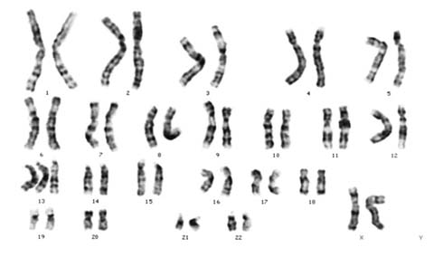

Questions:

- What is karyotyping used for?

- What sex is patient A?

- Does Patient A have one of the disorders listed in the table? If so, list the disorder and how you knew.

- Does Patient B have one of the disorders listed in the table? If so, list the disorder and how you knew.

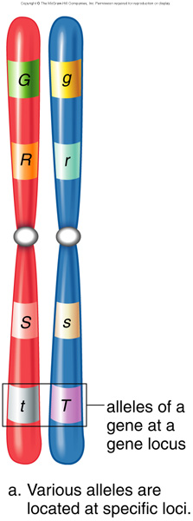
- What are two pieces of information you can get from a Karyotype?

- What is the normal diploid number for a human being?

- T/F The chromosomes shown to the right are homologous chromosomes.

- T/F Homologous chromosomes can contain different alleles for the same gene.

- T/F One chromosome is inherited from each parent in reproduction.

- T/F Two alleles that code for the same protein are called heterozygous, while two alleles that code for different proteins are called homozygous.

