Earth Forms | Oldest Piece of Rock
DINOSAURS  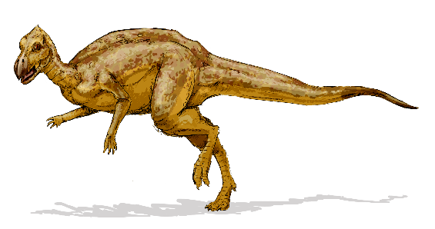 | FLOWERING PLANTS
FIRST FISH  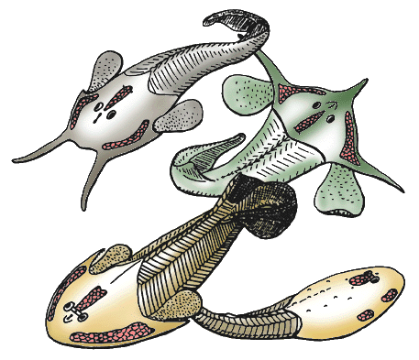 | 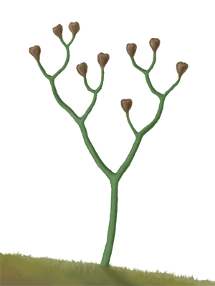  FIRST LAND PLANT
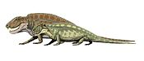  FIRST LAND ANIMALS | FIRST MAMMALS  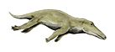
FIRST PRIMATE IN GENUS HOMO | HUMANS INHABIT NORTH AMERICA  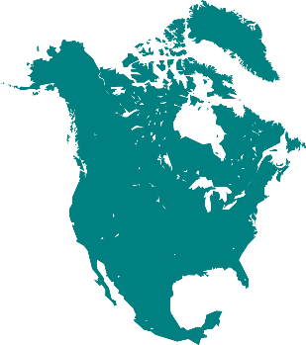
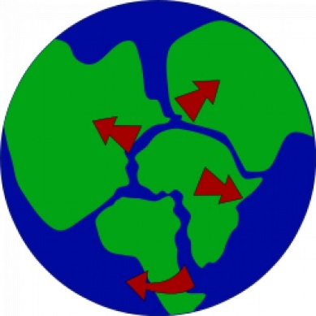  PANGEA SPLITS | 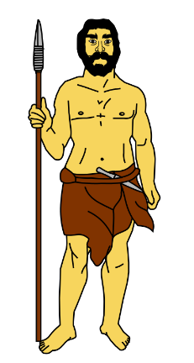  FIRST MAN

OXYGEN IN ATMOSPHERE | ALGAE FOSSILS  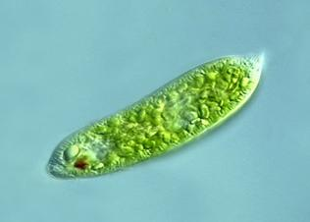
FIRST EVIDENCE OF LIFE | END OF ICE AGE  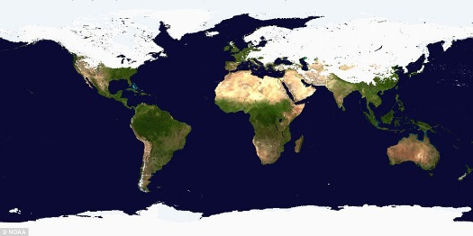
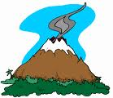  BEGINNING OF VOLCANIC ARC | MAMMALS AND FLOWERING PLANTS
FIRST FOSSIL OF COMPLEX ORGANISM | FIRST ABUNDANT LIFE FOUND IN ROCK RECORD

