CELL CYCLE FLIPBOOK Name: _______________________ Per: _____ Due Date: _____________
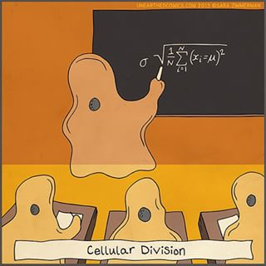
Learning Goal: Students will become familiar with the stages of mitosis and create an animation to illustrate the 6 basic steps of a cell’s life: Interphase, Prophase, Metaphase, Anaphase, Telophase and Cytokinesis.
Materials: sticky note pad, pencil, Biology textbook
Sample Flipbooks:
Valentine Flip Books: https://www.youtube.com/watch?v=cIQ1PnPdWlg
Mr. Otter Art Studio: https://www.youtube.com/watch?v=Njl-uqnmBGA

- Refer to the diagram on page 285 of your text for an overview of the phases of mitosis.
- Separate the sticky note pad and share with your neighbor. Use at least 30 sticky note pages.
- Create a title page on the front of your stack that includes your name and class period.
- Color is required on this assignment, so use it to your advantage.
- Your cells must have 3 chromosomes to start. Starting at the back of your sticky note stack, create an animation of the process of mitosis by drawing frames of animation on each page just like an old-school cartoonist. The frames need to be close enough together so that when you flip through your flipbook, it looks like an animation.
- THIS MAY TAKE MORE THAN ONE TRY! DRAW IN PENCIL so you can erase, and don’t forget, you can move the sticky notes around if you make a mistake.
- You are required to show at least 5 frames for each cycle of mitosis. If you need more than 5 frames to make each transition that is ok, but 5 is the minimum. For example you would begin in interphase and show five frames, slowly changing into prophase. To do this transition you would need to show the chromatin condensing, the centrioles separating, the spindle forming, and the breakdown of the nuclear envelope.
- Be sure to label each phase. In the previous example, each frame would be labeled appropriately as the cell is transitioning from interphase into prophase.
- When you are done, you should be able to flip though and see mitosis in action! Film it on your phone to show your friends and family. Post your video on You Tube to impress the world!

Hints:
- Make sure to draw in the same spot on each note so your cell does not jump around.
- Draw the phases near the bottom edge on the side opposite the sticky binder so flipping is easier.
- Label the phases near the edge on the left or right side or right above your cell.
- Use the previous “slide” as a guide for the size and position of items in your next cell drawing.
- Take your time and make it awesome! You can earn up to 3 extra points for creativity.

Grading Rubric:
Accuracy of drawings | 3 = perfect! | 2 = 1-2 mistakes | 1 = 3 or more mistakes | 0 = inaccurate
# of drawings/stage | 3 = 5 or more | 2 = 4 per stage | 1 = 3 per stage | 0 = 2 or fewer
Coloring | 3 = fantastic! | 2 = good effort! | 1 = no color or messy | 0 = uh oh
Labels | 3 = all labeled | 2 = 4 labels | 1 = 3 labels | 0 = 2 or fewer
Neatness | 3 = great job! | 2 = some effort | 1 = try harder next time | 0 = big yawn!
TOTAL: _____________/15

