Name: _________________________________ Period: _______

CELLS – THE BASIC UNITS OF LIFE

Problem: What are cells? What features distinguish plant cells from animal cells?

More than 300 years ago, the English scientist Robert Hooke first described the cavities in sliced cork as “cells.” The cork cells Hooke examined were actually empty shells that had once contained live material. In the early part of the 19th century, the German biologists Schleiden and Schwann realized that all living things – plants and animals – are made up of cells. This understanding eventually established the cell theory: the cell is the basic unit of structure and function of all living things.

DON’T FORGET TO USE YOUR MICROSCOPE DRAWING GUIDELINES DURING THIS LAB!!

Materials:

Microscope slides cover slips forceps
Bottle cork onion iodine stain razor blade, single edge
Colored pencils human cheek cells toothpick methylene blue

Investigation:

A. CORK
Carefully shave a very thin section from a bottle cork with a single-edged razor blade. Prepare a wet mount of the cork slide. Examine the cork specimen under low power, studying it in different positions. Then examine the specimen under medium and under high power. Remember: Do not use the coarse adjustment while viewing with any power other than low!!! Prepare 2 fields of view and sketch your observations of the cork on Low and High power. Be sure to follow the proper format for fields of view.

1. How would you describe the units that compose the cork? ________________________________________
____________________________________________________________________________________

2. Describe the shapes and sizes of the individual units. ____________________________________________
____________________________________________________________________________________

3. What do you see inside the units? ___________________________________________________________

4. Are there spaces between the cells? __________________________________________________________

5. Are these cells living or nonliving? Explain. __________________________________________________
____________________________________________________________________________________

B. ONION
The epidermis (outer layer) of the onion is ideal for cell study because it is composed of a single layer of cells. As you study these cells, you are looking into functioning units of living material.

Cut an onion lengthwise. Remove a thick scale and peel the delicate transparent tissue from the inner surface. Cut a square of the tissue and mount it on a slide in a drop of water. (NOTE: Avoid wrinkling the tissue.) Add a cover glass to your wet mount. Then examine the living cells under low power.

6. What is the shape of the cells? ______________________________________________________________

7. Are all the cells similar in shape? ___________________________________________________________

8. What color is the living cytoplasm? __________________________________________________________

Carefully raise one side of the cover glass and add a drop of iodine stain. Select one cell that shows the contents clearly. Move it to the center of the microscope field. Using high power, examine all the parts of the cell. Prepare a field of view (high power) and sketch your observations. LABEL: cell wall, plasma membrane, cytoplasm, and nucleus.

9. When you add a drop of iodine, what effect does the stain have on the cells? _________________________
____________________________________________________________________________________

Choose one cell that is easy to see. Examine its parts and answer these questions.

10. What is the appearance of the cytoplasm? ____________________________________________________
____________________________________________________________________________________

11. What is the appearance of the nucleus? ______________________________________________________
___________________________________________________________________________________

12. Are the nuclei in the same position in all of the cells? _________________________________________

13. Does the onion epidermal cell have depth? __________________ Explain. ________________________
____________________________________________________________________________________

C. CHEEK

Gently scrape the inside of your cheek with a clean toothpick. Prepare a wet mount of the material that you have scraped. Add a drop of methylene blue and a cover glass. Examine the cells under low power of the microscope. Switch to medium and focus, then switch to high power. Carefully look for the outer edge of the cytoplasm. Prepare a field of view. Draw a single cheek cell as you observed it under high power. LABEL: plasma membrane, cytoplasm, and nucleus.

14. How does the outer edge of the cheek cells compare with the outer edge of the onion cells? __________
__________________________________________________________________________________

15. What is this outer edge called? ___________________________________________________________

16. Describe the shape of cheek cells. _________________________________________________________
___________________________________________________________________________________

17. How did the cork units differ from those of the onion and cheek cells? _____________________________
____________________________________________________________________________________

18. What are the differences between plant and animal cells? _______________________________________
____________________________________________________________________________________

19. What is the outer covering of an onion cell called? _____________________________________________

20. What is the basic unit of structure in all living things? __________________________________________

D. GREEN ALGAE --Prepared Slide

Choose a prepared slide of the green algae. Examine the cells under low power of the microscope. Switch to medium and focus, then to high power. Carefully look for the outer edge of the cytoplasm. Prepare a field of view. Draw a single algae cell as you observed it under high power. LABEL: plasma membrane, cell wall, cytoplasm, and nucleus.

14. How does the outer edge of the algae cells compare with the outer edge of the cheek cells? __________
__________________________________________________________________________________

15. What is this outer edge called? ___________________________________________________________

16. Describe the shape of algae cells. _________________________________________________________

17. How did the algae cells differ from those of the onion and cheek cells? _________________________________________________________________________________________

In the space below, make a Venn Diagram to compare and contrast the four cells we looked at in this lab.

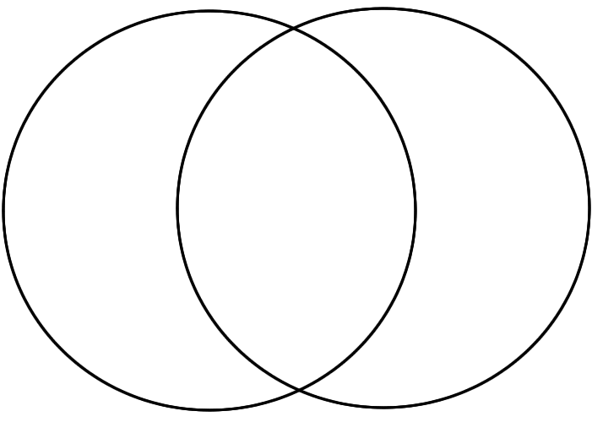
PLANT CELLS BOTH ANIMAL CELLS

