Graphing 101
Once you have collected your data, you will need to present it to your teacher and classmates in an organized way. In a science publication, you would choose between a table and a graph, but for our class it is required to report the data in both forms. You will use your DATA TABLE to make a GRAPH.
Type of graphs: Your first choice is to determine which type of graph would best communicate your findings. Your basic choices are bar graph, line graph, pie chart, or scatter plot.

BAR GRAPH – This is the most common type for science fair projects. You may select a bar graph when your independent variable is qualitative (categories) or quantitative (numbers).
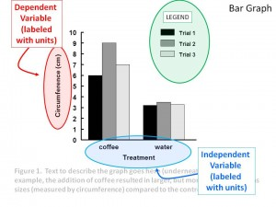
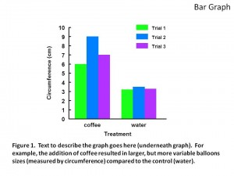

LINE GRAPH – This is the second most common, but frequently used incorrectly, so be careful here. You should only select a line graph if your independent variable is quantitative (numbers) and you hypothesized that the changes in the independent variable would result in changes in the dependent one. For example, line graphs are great for showing changes in the dependent variable over time or distance along a transect. Again, double check the axes!
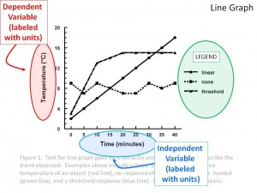
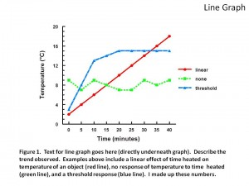

PIE CHART – Pie charts are good for projects that have qualitative independent variables and have generated data that can be expressed as percentages of the total. For example, if your data were counts (i.e. the number of times something happened), then this might be your best choice to compare different treatments.
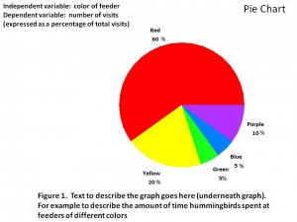
SCATTER PLOT – If the purpose is to see if the variables are related (common in environmental projects), then a scatter plot would be your best choice. This option typically requires much more data than the others to observe a trend. X-Y plots are used to determine relationships between the two different things. The x-axis is used to measure one event (or variable) and the y-axis is used to measure the other. If both variables increase at the same time, they have a positive or direct relationship. If that direct relationship is exact and follows a perfectly straight line, it is called a constant direct relationship. If one variable decreases while the other increases, they have a negative or indirect relationship. Sometimes the variables don't follow any pattern and have no relationship.
Scatter plots are also called X-Y plots, and a “line of best fit” is often used to show a connection.
Data can be interpolated or extrapolated based on the best fit line. Interpolate: To make predictions about points within the recorded data. Extrapolate: To make predictions about data not yet recorded, like what might happen in the future based on the trends seen in the graphed data.
