LEAF MODEL INSTRUCTIONS
See p. 681 of your text for a cross-section

Name: _______________________________Per:____________
Use Google Images to choose a leaf blade shape. You must model your leaf after a real plant and identify the species on your leaf model. Want to be seasonal? Choose holly, poinsettia, or ivy.
Model Labels Checklist:
First and last name, Class period
- Plant species name
- stem
- epidermis (upper & lower)
- cuticle (upper & lower)
- stoma
- guard cells
- vascular bundle (veins)
  - xylem
  - phloem
- palisade mesophyll
  - chloroplasts
  - accessory pigments
- spongy mesophyll
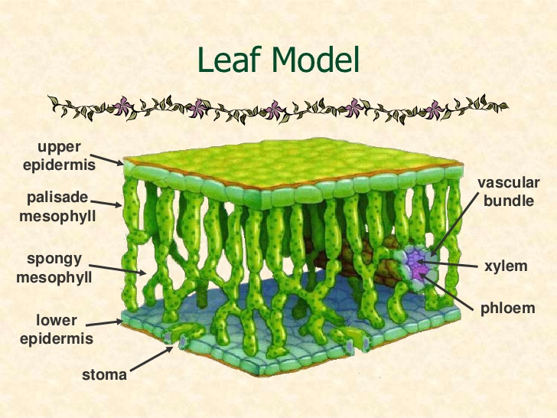

Materials and procedure:
- green construction paper = epidermis
  - cut matching epidermis pieces (top & bottom) Your leaf must be at least 20 cm long. Label the species of leaf, your full name and your class period.
  - Don’t forget to leave a stem on one end of your leaf!
  - use hole punch to make 8 stomata on the bottom epidermis.
- hole protectors = guard cells
  - use a sharpie to draw the two guard cell subunits
- wax paper = cuticle (top & bottom)
  - cut pieces to make them the same shape as your leaf. Tape* on top and bottom.
- 4 straws = vascular bundle (veins)
  - hot glue 2 together to represent xylem & phloem
  - cut 2 in half to act as 4 pillars to support upper epidermis at the corners
- adding machine tape = palisade mesophyll cells
  - draw and trim lower edge of mesophyll cells
  - color cells & add chloroplasts and two other accessory pigments
  - tape upper edge of palisade mesophyll to edge of upper surface of leaf
- packing styrofoam = spongy mesophyll
  - hot glue to your bottom leaf inside

Add the following labels to help describe how the leaf helps in photosynthesis:
a flag labeled “H₂O” coming out of the xylem (use a toothpick)
a flag labeled “carbs” coming out of the phloem (use a toothpick)
a pipe cleaner showing “oxygen” moving into the stomata
a pipe cleaner showing “carbon dioxide” moving out of the stomata

*Note: Hot glue does not work with wax paper. Cuticle must be taped to epidermis.

