**Metric Measurement Lab**

**Objectives**:

* You will learn to make measurements using the metric system.
* These measurements will encompass mastering the metric ruler, gram scale, graduated cylinder, and thermometer.
* You will demonstrate your ability to convert the original measurements to lower and higher values by moving the decimal point the correct number of places in the proper direction.

**Materials**:

* Lab paper
* metric stick
* Glassware: graduated cylinders, beaker
* coins
* Book
* Gram Scale
* Thermometer

**Procedures and Data:**

[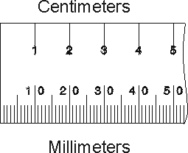](http://decemberbabyblog.files.wordpress.com/2007/05/cm-mm-ruler2.gif)

1. **Linear Measure**

Use the metric stick to measure the items listed below. Place your measurements in the spaces below. Above each column write the name of the unit that is abbreviated below it. Circle the unit you used to directly measure with for each item. You will need to convert for the other units.

|  |  |  |  |  |
| --- | --- | --- | --- | --- |
| **Diameter of Penny** | ____________**m**. | ____________**cm.** | ___________**mm.** | ____________**km.** |
| **Height of lab counter** | ____________**m.** | ____________**cm.** | ___________**mm.** | ____________**km.** |
| **Width of the Textbook** | ____________**m.** | ____________**cm.** | ___________**mm.** | ____________**km.** |
| **Length of the Room** | ____________**m.** | ____________**cm** | ___________**mm.** | ____________**km.** |

1a. Did you use the same unit to measure each item? Explain why you selected the units you did.

**2. Mass/Weight**

[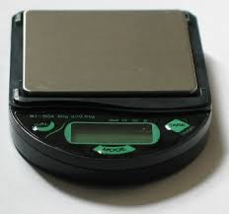](http://images.google.com/imgres?imgurl=http://www.garrettsbridges.com/images/scale2.jpg&imgrefurl=http://www.garrettsbridges.com/building/beautiful-new-gram-scale&h=332&w=354&sz=22&hl=en&start=3&um=1&tbnid=vFxFZ2zh1StB8M:&tbnh=113&tbnw=121&prev=/images?q=gram+scale&ndsp=20&um=1&hl=en&rlz=1T4DKUS_enUS213US213&sa=N)

Use the scale to mass the following materials. Place your measurements in the spaces below. **Be sure to check the unit on the scale to verify that you are measuring in grams (g) NOT oz or ct.**

Write the name of the unit above the columns below.

|  |  |  |  |  |
| --- | --- | --- | --- | --- |
| **Mass of coin** | ____________**g**. | ___________**_cg.** | ___________**mg.** | ____________**kg.** |
| **Mass of dollar** | ____________**g.** | ____________**cg.** | ___________**mg.** | ____________**kg.** |
| **Mass of empty 10 ml graduated cylinder** | ____________**g.** | _________**cg.** | _________**mg.** | ___________**kg.** |
| **Mass of graduated cylinder with 10 ml water** | ____________**g.** | _________**cg.** | _________**mg.** | ___________**kg.** |
| **Mass of 10 ml water** | ____________**g.** | _________**cg.** | _________**mg.** | ___________**kg.** |

2a. What is the difference between weight and mass?

2b. Why are they used synonymously on Earth?

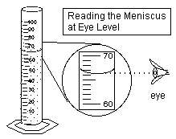**3. Volume (of liquids)**

Use the glassware provided to measure the volume of the following containers. Place your measurements in the space below. In the last column of the chart write which glassware you used to measure the liquid with. (10 ml graduated cylinder, 50 ml graduated cylinder, 50 ml beaker, 100 ml beaker, 100 ml graduated cylinder, etc.)

|  |  |  |  |  |  |
| --- | --- | --- | --- | --- | --- |
| **Volume of the purple liquid** | _________**L**. | ______**_cl.** | _______**ml.** | |  |
| **Volume of water** | _________**L.** | _______**cl.** | _______**ml.** | |  |
| **Volume of the bottle _______** | _________**L.** | _______**cl.** | _______**ml.** |  | |

3a. Do all of the glassware measure with the same degree of accuracy? Explain

3b.What determines which glassware you measure with?

3c. What is a meniscus? Why is it necessary to know about it when measuring liquids?

**4. Temperature**

Use the thermometer to measure the temperature of the following items. Write the name of the unit measure above the column that contains its abbreviation. Circle the temperature/s which you were able to measure directly.

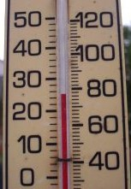

|  |  |  |  |
| --- | --- | --- | --- |
| Ice water | F | C | K |
| Boiling water | F | C | K |
| Room temperature | F | C | K |
| Cold Isopropyl alcohol | F | C | K |

4a. How did you determine the values for K?

**Summary**:

1. What is the metric SI unit used for measuring length? ________________________.

2. The metric prefix denoting 1000X is _____________________.

3. If you are changing m to cm. what direction do you move the decimal point? _______

4. How many times larger is a centigram then a milligram? _______________.

5. What is the metric value for mass? _____________________________

6. What is the metric value for length or distance? ________________

7. What is the prefix value for 100X? _____________

8. What is the prefix value for 1/100? _____________

9. If we are moving from a large value to a small value, we move the decimal point to the ______________.

10. If we are moving the decimal point to the right we are moving from a ___________ value to a ____________ value.

11. Convert the following measurements.

a. 1.2 km = ___________m d. 25 C = ___________ F g. BONUS (SHOW WORK)

b. 13 g = ______________kg e. 100 C = ___________ K 5 km = ____________ feet

c. 1205 mL = __________ L f. 5000 km = _________ mm

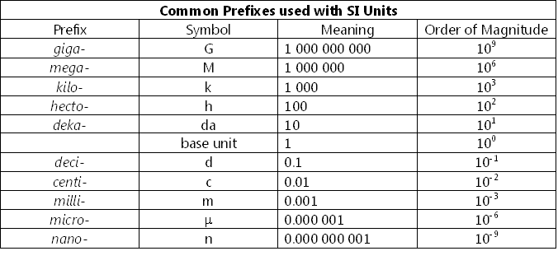

|  |  |  |  |  |
| --- | --- | --- | --- | --- |
|  |  |  |  |  |
| **Common Conversions**   |  |  |  | | --- | --- | --- | | **SI (System International) vs. the metric system** | | | | **Measurement** | **SI Base Unit** | **Metric Unit** | | Length | meter | meter | | Mass | kilogram | gram | | Temperature | kelvin | Celsius | | | | | | |
| **Length - meter (m)** | | | | | |
| 1 meter (m) = 39.37 inches (in) | | | | | |
| 1 kilometer (km) = .62 miles (mi) | | | | | |
|  | | | | | |
| **Volume - liter (L or l)** | | | | | |
| 1 liter (l) = 1.06 quarts | | | | | |
| 1 milliliter (ml) = .034 fluid ounce | | | | | |
| 1 ml = 1cm3 | | | | | |
|  | | | | | |
| **Mass - gram (g)** | | | | | |
| 1 pound (lb) = 454 grams (g) | | | | | |
| 1 kilogram (kg) = 2.2 pounds | | | | | |
|  | | | | | |
| **Temperature - Celsius (°C)** | | | | | |
| °F = 1.8 (°C) + 32 °C = (°F -32) | | | | | |
| 1.8 | | | | | |
| °C = K - 273 | | | | | |